In this lab, we investigate the management of a notional (and very simplified) VLAN-based distribution layer backbone network. The startup software development firm you work for occupies three floors of an office building. The firm is structured as a matrixed organization, with development teams composed of a software engineer (SE), a tester/quality assurance engineer (QA), and a marketing/sales/business development representative (MSB). These teams sit together in bullpen areas, with 2 teams on each floor. This integrated product team approach works well in many ways, but presents a challenge for network administration. While traditional networks are often segmented according to physical location, this network needs to be segmented according to function, with the SE, QA and MSB members being connected to their own function-oriented subnets. Fortunately, the building has already been equipped with a VLAN-capable switch on each floor, with VLAN Switch 1 including a connection to a traditional router, as pictured in the figure. The router includes NAT capability, assigning private IP addresses within the building network in the 192.168.x.x range.

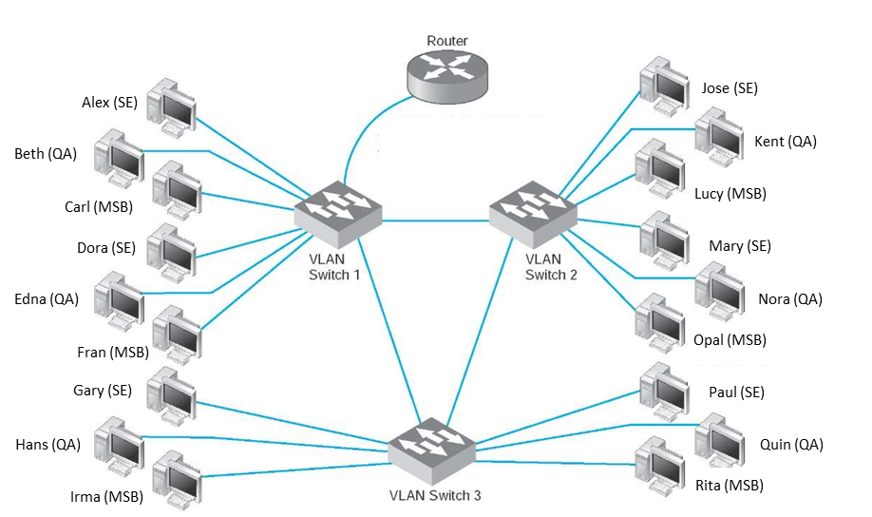

Your job is to assign VLAN IDs and IP addresses consistent with a network segmentation scheme such that each SE member belongs to a subnet which includes all other SE members, each QA member belongs to a subnet which includes all other QA members, and each MSB member belongs to a subnet which includes all other MSB members. There are many possible correct solutions, limited by the IP addressing range, subnetting rules and VLAN address space. To complete the assignment, **upload a Word (.docx) or Adobe (.pdf) file with a VLAN ID to Subnet legend, and a table or clearly readable list identifying the VLAN ID and IP address for each employee as identified in the figure as your submission to this assignment in Blackboard**.

Sample Assignment Solution Response Format:

Network ID : 192.168.4.0/24

VLAN ID: _10_ <-> Subnet: 192.168._4_._64_/_26_

VLAN ID: _20_ <-> Subnet: 192.168._4_._128_/_26_

VLAN ID: _30_ <-> Subnet: 192.168._4_._192_/_26_

Switch 1

Alex (SE) VLAN ID: _10_ IP: 192.168._4_._61_

Beth (QA) VLAN ID: _20_ IP: 192.168._4_._140_

Carl (MSB) VLAN ID: _30_ IP: 192.168._4_.__200_

Dora (SE) VLAN ID: _10_ IP: 192.168._4_._62_

Edna (QA) VLAN ID: _20_ IP: 192.168._4_._141_

Fran (MSB) VLAN ID: _30_ IP: 192.168._4_._201_

Switch 2

Jose (SE) VLAN ID: _10_ IP: 192.168._4_._70_

Kent (QA) VLAN ID: _20_ IP: 192.168._4_._150_

Lucy (MSB) VLAN ID: _30_ IP: 192.168._4_._210_

Mary (SE) VLAN ID: _10_ IP: 192.168._4_._71_

Nora (QA) VLAN ID: _20_ IP: 192.168._4_._151_

Opal (MSB) VLAN ID: _30_ IP: 192.168._4_._211_

Switch 3

Gary (SE) VLAN ID: _10_ IP: 192.168._4_._80_

Hans (QA) VLAN ID: _20_ IP: 192.168._4_._160_

Irma (MSB) VLAN ID: _30_ IP: 192.168._4_._220_

Paul (SE) VLAN ID: _10_ IP: 192.168._4_._81_

Quin (QA) VLAN ID: _20_ IP: 192.168._4_._161_

Rita (MSB) VLAN ID: _30_ IP: 192.168._4_._221_